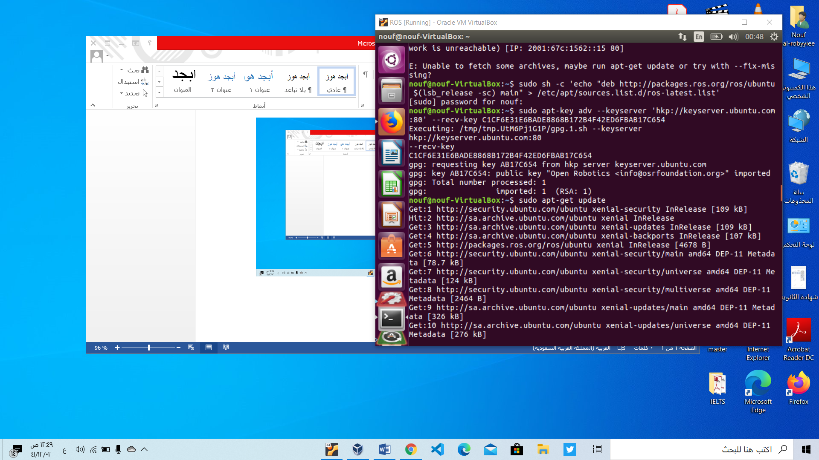

Setup your computer to accept software from packages.ros.org and your key.by this two command then make sure your Ubuntu package index is up-to-date:

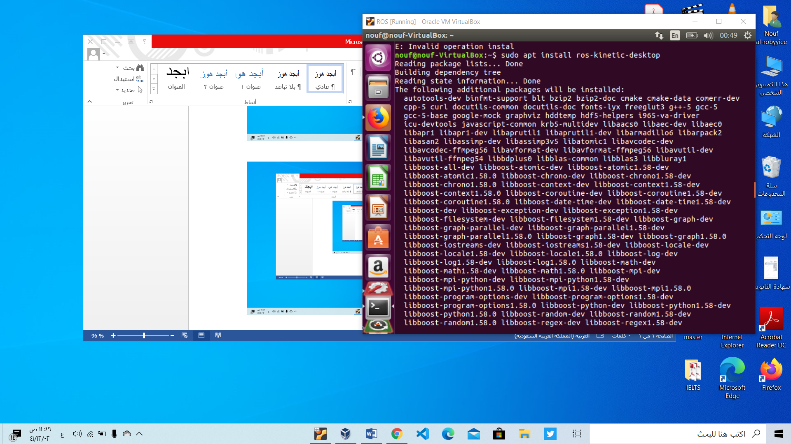

There are many different libraries and tools in ROS. We use this command to install it

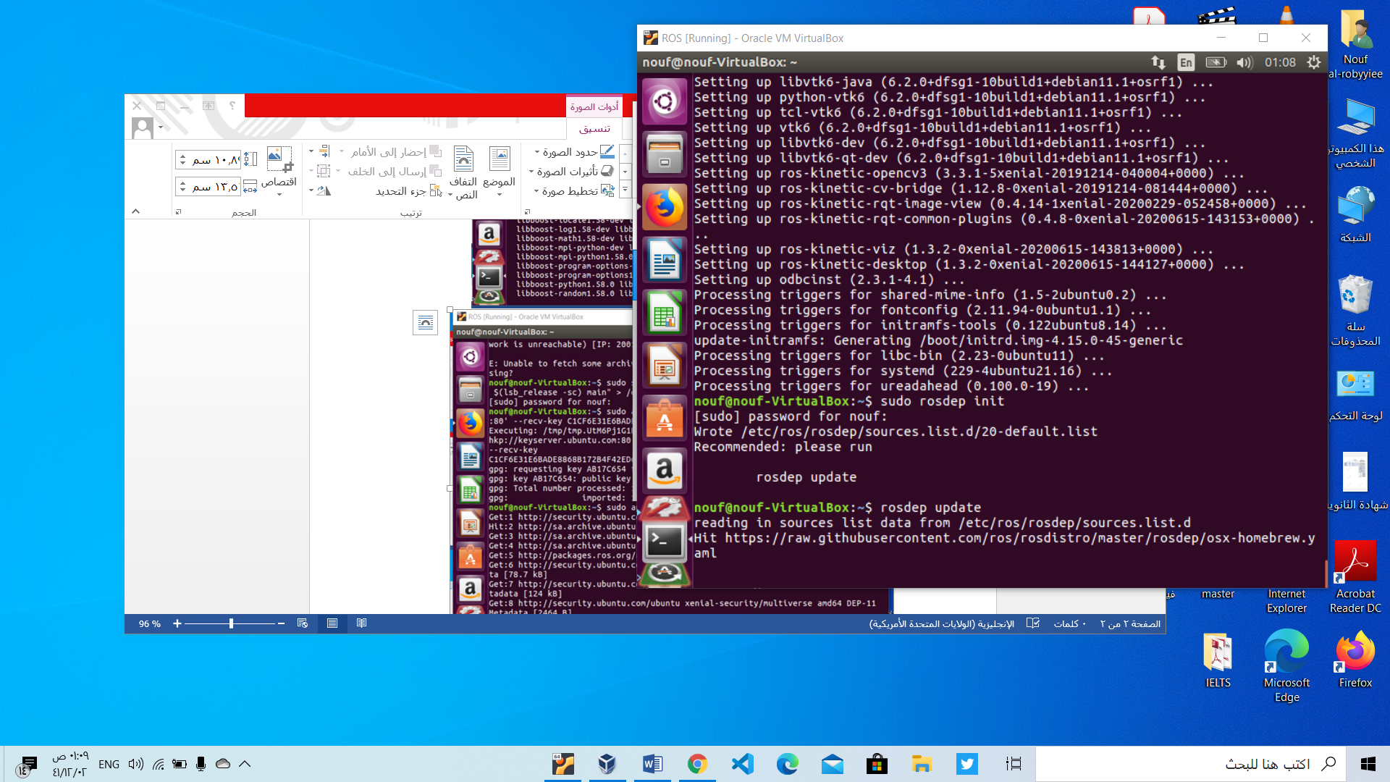

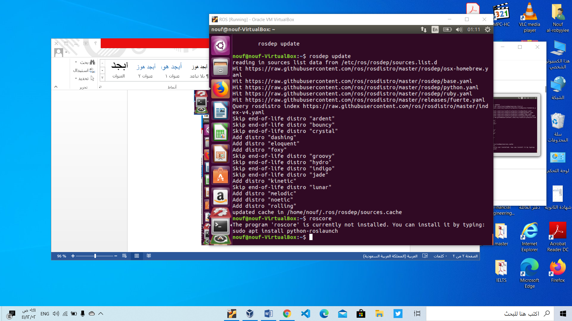

you can initialize rosdep by this two command.

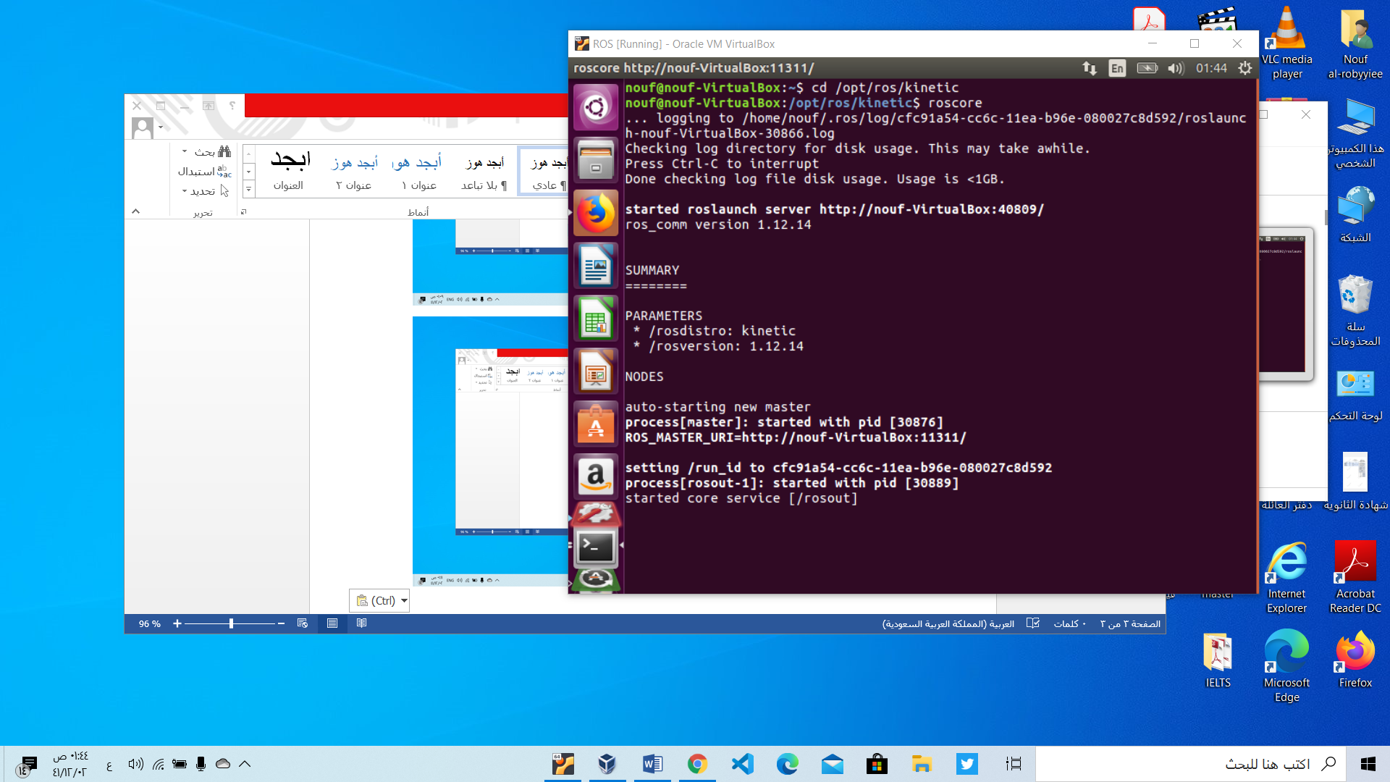

It is succefully instllation ROS

**To create pakage :**

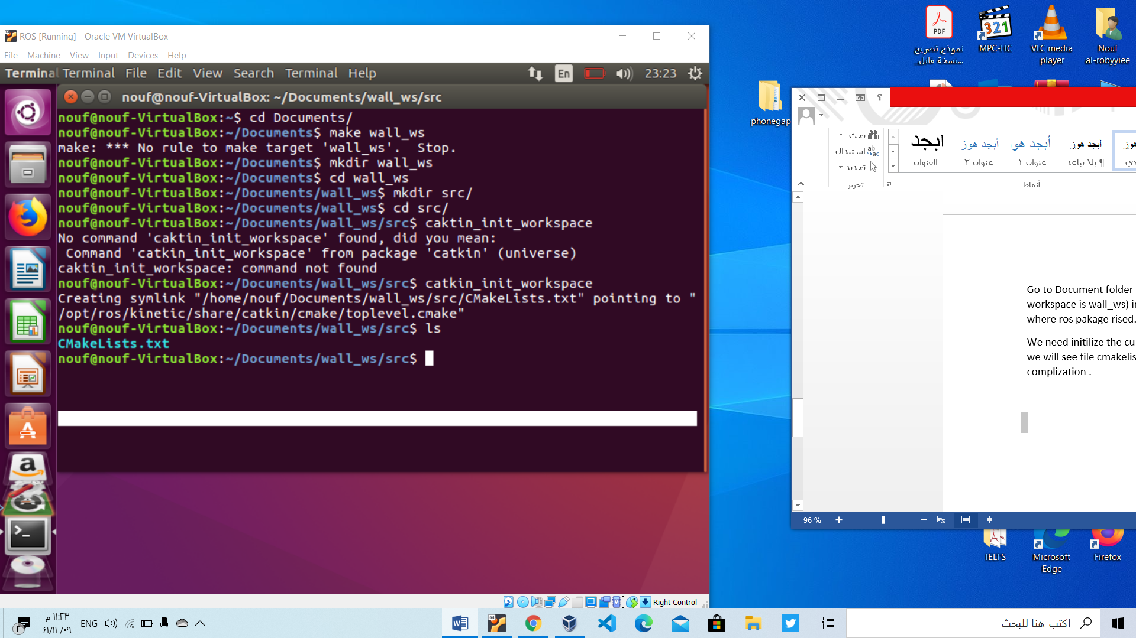Go to Document folder and create folder that well be your work spase (our workspace is wall_ws) inside wall_ws folder create sorce folder we name it src. Src is where ros pakage rised.

We need initilize the current dirctory by catkin_init_workspace after this command we will see file cmakelists.txt is created. It means the empty workspace ready to

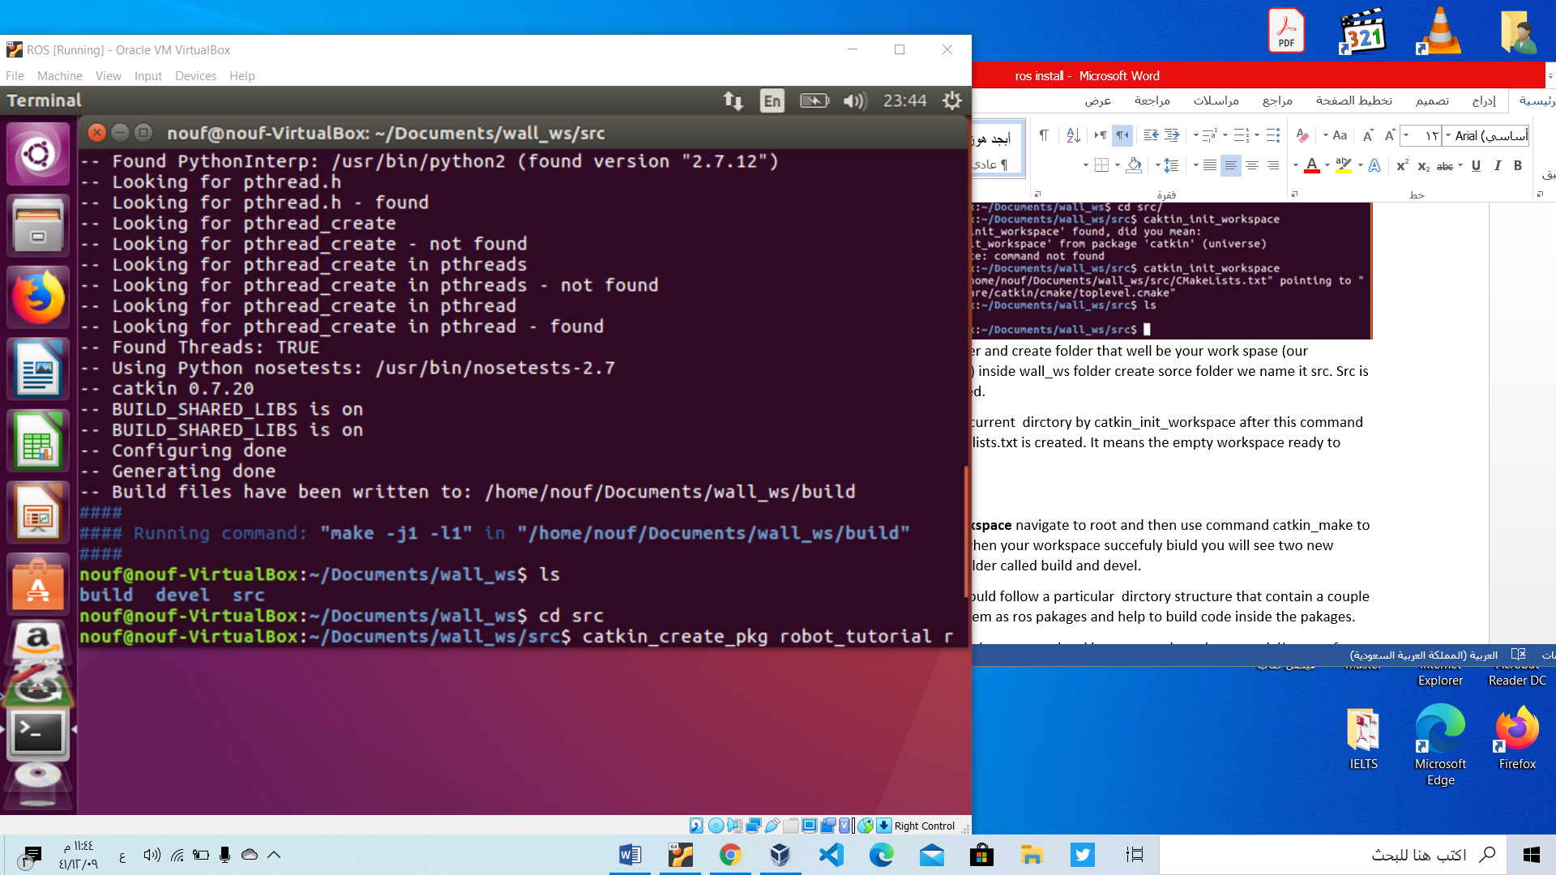

**To compile your workspace** navigate to root and then use command catkin_make to biuld your prossec . when your workspace succefuly biuld you will see two new folders in you roor folder called build and devel.

In ROS pakage We should follow a particular dirctory structure that contain a couple of files that identfy them as ros pakages and help to build code inside the pakages.

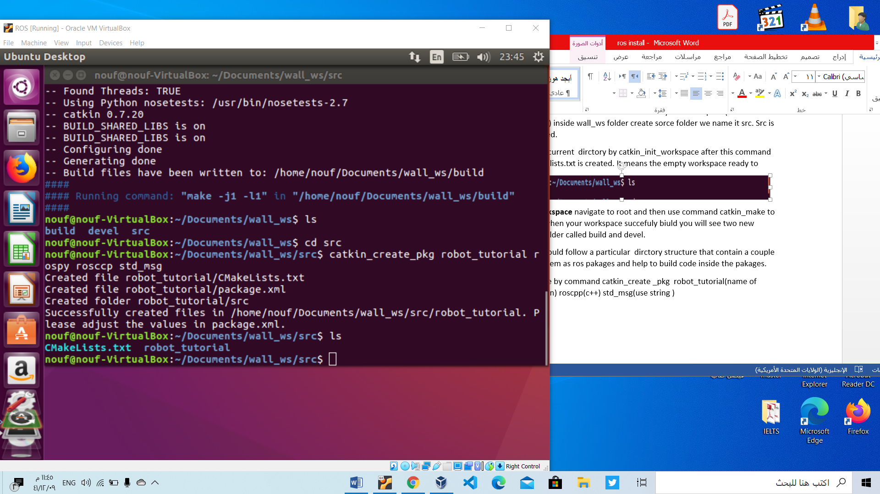

To create your pakage by command catkin_create _pkg robot_tutorial(name of bakage) rospy (python) roscpp(c++) std_msg(use string )